**PROGRAM 7**

**Aim**

To write a Python program to solve the **8-Puzzle Problem** using the Breadth-First Search (BFS) algorithm.

**Algorithm**

1. Start with an **initial state** of the 8-puzzle (3×3 matrix).
2. Define the **goal state** of the puzzle.
3. Use a queue (BFS) to store puzzle states and explore them in FIFO order.
4. For the current state:
   * Locate the blank tile (0).
   * Generate possible moves (up, down, left, right).
   * Create new states by swapping the blank with adjacent tiles.
   * If a new state matches the goal → Success.
   * Otherwise, enqueue it if not already visited.
5. Repeat until the goal state is reached or all possibilities are explored.

CODE :

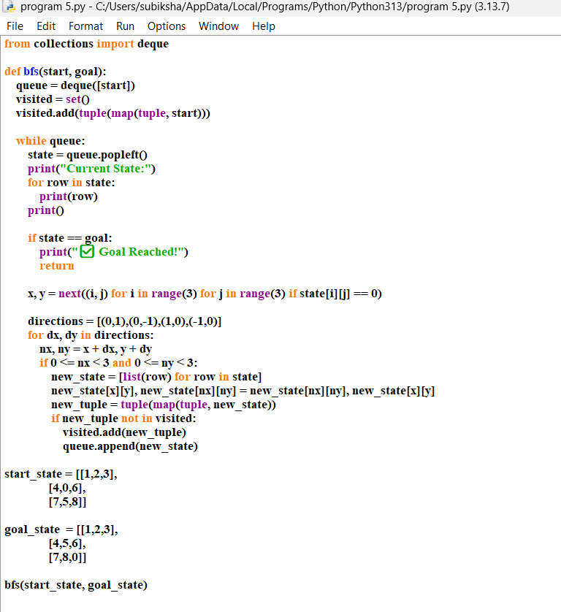

OUTPUT:

